Multiplying and Dividing Integers

When you multiply two integers with the same signs, the result is always positive. Just multiply the absolute values and make the answer positive.
Positive x positive = positive
Negative x negative = positive
When you multiply two integers with different signs, the result is always negative. Just multiply the absolute values and make the answer negative.
Positive x negative = negative
Negative x positive = negative
When you divide two integers with the same sign, the result is always positive. Just divide the absolute values and make the answer positive.
Positive ÷ positive = positive
Negative ÷ negative = positive
Negative ÷ positive = positive
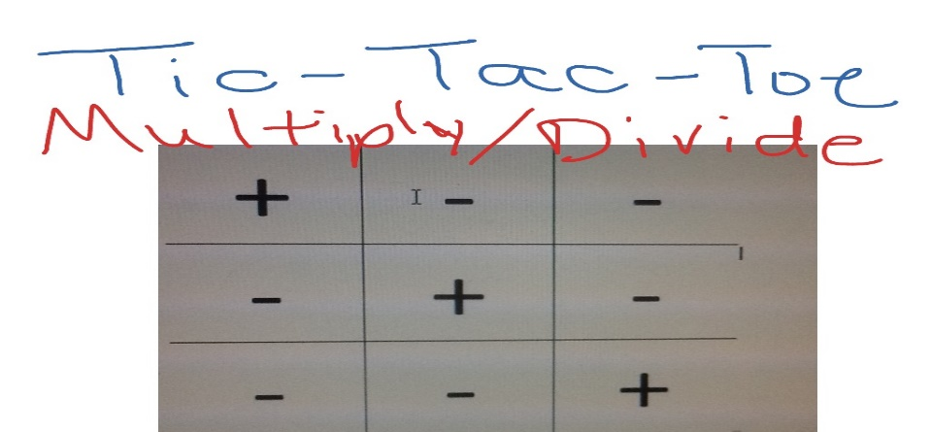

Practice Website
https://www.khanacademy.org/math/in-seventh-grade-math/india-integers/division-integers/e/multiplying_and_dividing_negative_numbers

Practice Problems
